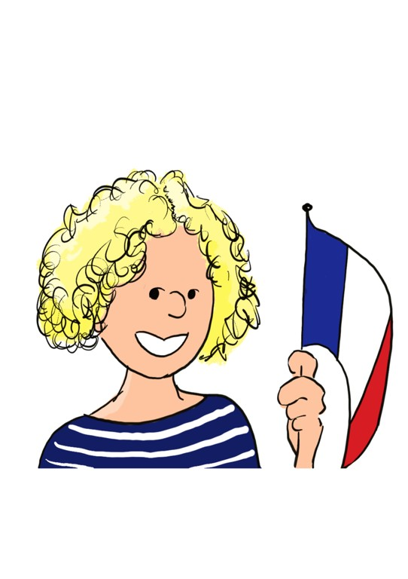

A L’Aise en Français chez Victoria
mail@victoriaward.org.uk 07484 250 537

What?
Guided conversational French in a convivial, ‘club’ atmosphere accompanied by refreshments.
The primary focus will be on listening and speaking everyday French (with some written follow-up to consolidate grammar points/vocabulary).
Active learning (e.g. role-plays/dialogues, video extracts, games, recipes) with plenty of opportunity to practise and share. We will follow and revisit themes in order to grow and review vocabulary.

Where?
Chez Victoria – in Hereford. Easy parking nearby.

When?
Two groups:
Weds am – 10:30 – 11:45
Weds pm – 2:30 – 3:45.

Who?
People with the desire to improve their speaking ability and vocabulary. Places limited to 6. Minimum participants 4.

Cost?
£15 per 1hr 15 min session (including refreshments)
Payable upfront starting with an initial trial period of 3 weeks. Following the trial period, payable upfront in 5-week termly blocks.

